Development Specifications Document (DSD)

*Process Name: <Employment Adjudication Process>*

Table of Contents

**Document Overview** **1**

Automated Master Project Details **1**

Runtime Guide **1**

Runtime Diagram 1

List of Packages 2

Master Project Runtime Details 2

**Project Details** **3**

Project Name: <project name> 3

Workflow(s) specific to the Project 4

Project Name: <project name> 4

Workflow(s) specific to the Project 5

**Compliance Considerations and Reporting Requirements** **5**

**Other Details** **6**

Future Improvements 6

Debugging Tips 6

Other Remarks 6

**Post UAT Specifications** **6**

**Glossary** **6**

Version Control

|  |  |  |  |  |  |  |
| --- | --- | --- | --- | --- | --- | --- |
| Date | Version | Role | Name | Organization Department | Function | Comments |
| 08/24/2021 | 1.0 | Author | Purnima | USCIS | US Immigration department | It’s a prototype only |



# Document Overview

The Development Specifications Document (DSD) is created for every business process automated using RPA. The DSD needs to be reviewed and updated for every change requested and applied to the automated process. This document provides a technical snapshot and must always reflect the latest design and key features of the automated workflow.

The document naming convention will follow the naming convention and the version of the automated process. This can be “business process name version” or it can be defined, case by case, as part of the larger RPA project design.

This document is completed by the RPA Solution architect and RPA developer who automates the business process. It is reviewed by the business process owner, application owner, and CoE design authority.

This document is meant to assist the RPA COE, IT operations and process owners by providing a snapshot of the automated process details and components. It can also serve developers to have a quick glance at the setup, before diving into the code, to troubleshoot or update changes. The purpose of the document is to record the outcome specific to the automated master project and its subcomponents: projects, workflows, sequences etc.

# Automated Master Project Details

Details filled in by the developer reflect the actual information for the master project released for production.

|  |  |  |
| --- | --- | --- |
| # | Item | Details  Fill in with free text. If not applicable, mark the filed as "N/A". No empty fields. |
| 1 | Master Project Name and Version | Employment Adjudication Process Version 1 |
| 2 | Robot Type (attended/unattended/mix) | Attended |
| 3 | Is Orchestrator used? (Yes/No) | Yes |
| 4 | Scalable? (Yes/No)  Can the process be run by multiple robots in parallel? | Yes |

# Runtime Guide

## Runtime Diagram

**Architectural Structure of the Master Project** Display the interaction between components (package / robots, Orchestrator queues, and running order).

**Level 0 diagram of EAD_Dispatcher Process- MainFlow**

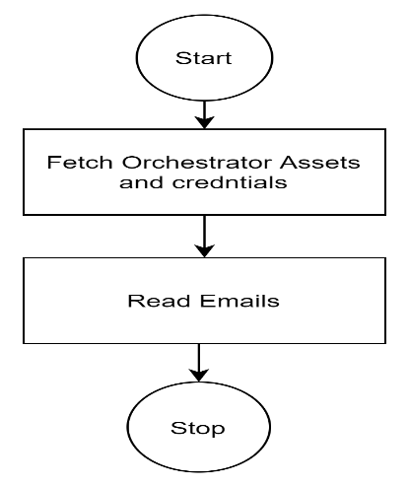

Level 1diagram of EAD Dispatcher Process- Read Emails

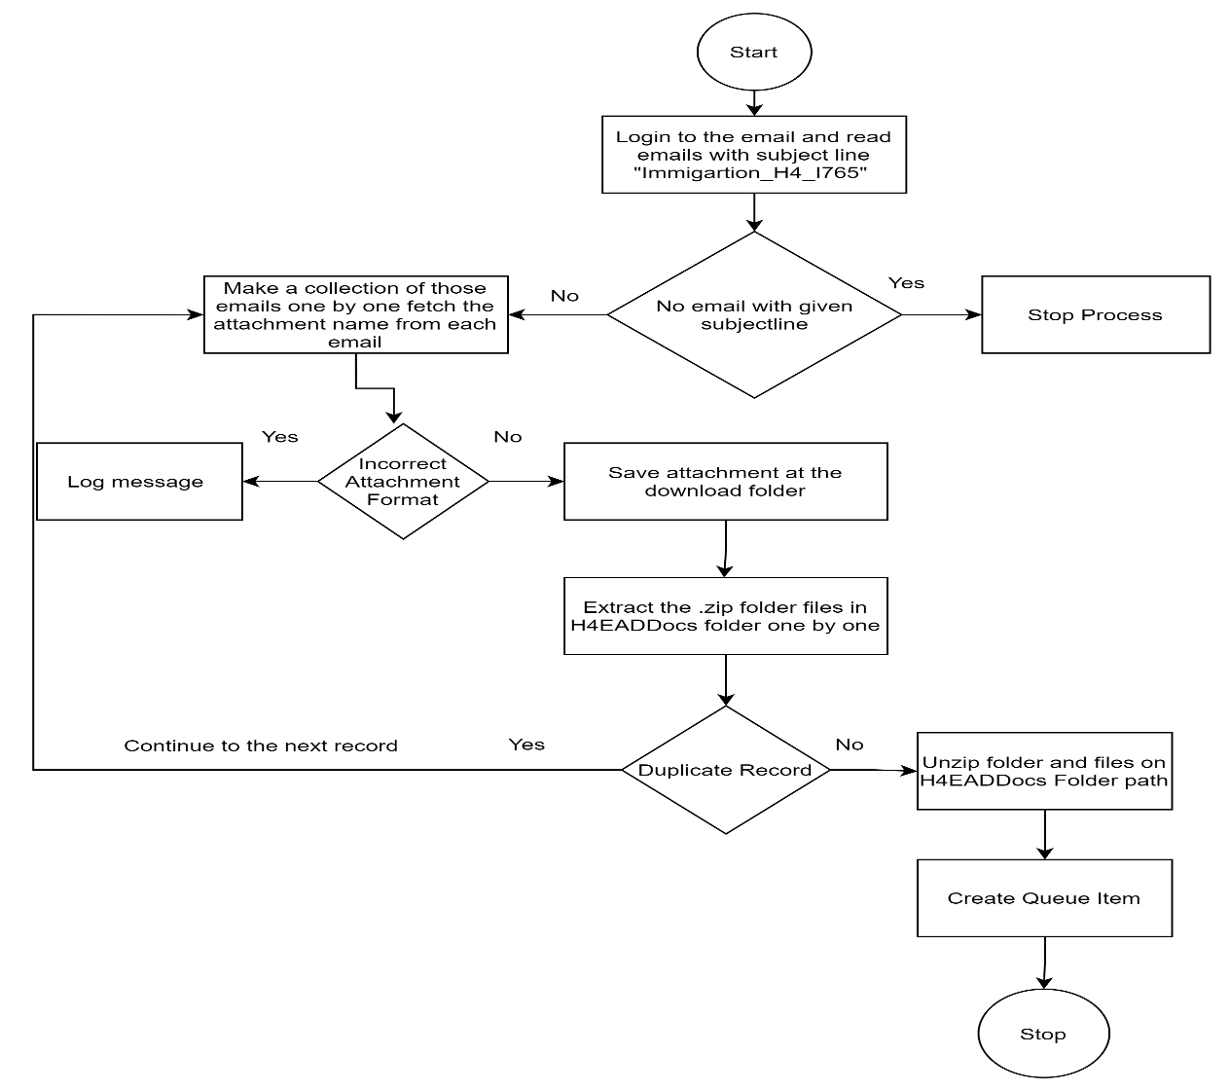

Level 2 diagram for EAD_Dispatcher Process- Create Queue Item

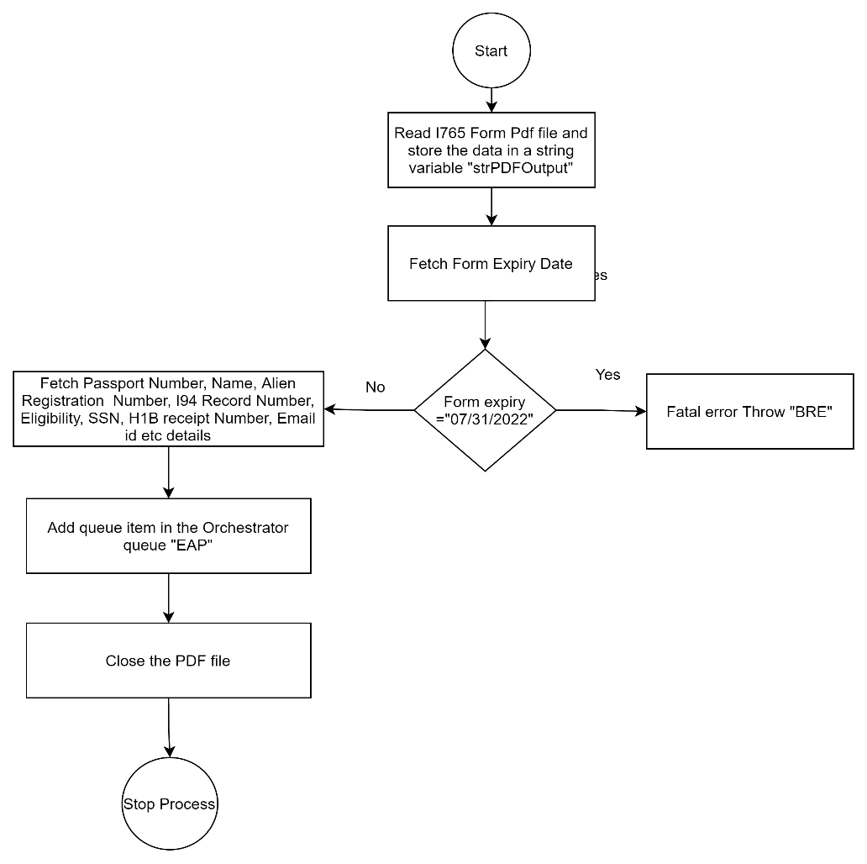

Level-0 Diagram of EAD_Processor Process – Main Flowchart

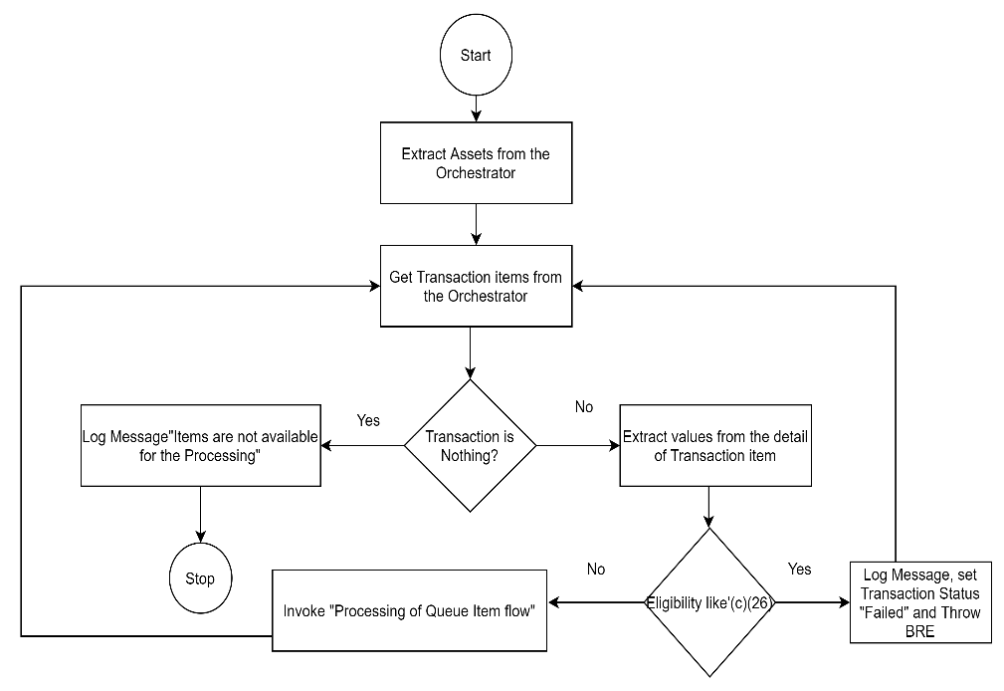

Level- 1 Diagram of EAD_Processor Process –

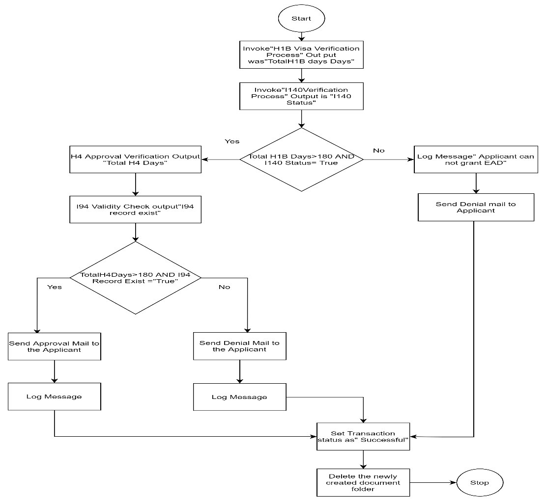

Level-2 Diagram of EAD_Processor Process

1—H1B Visa Verification Process

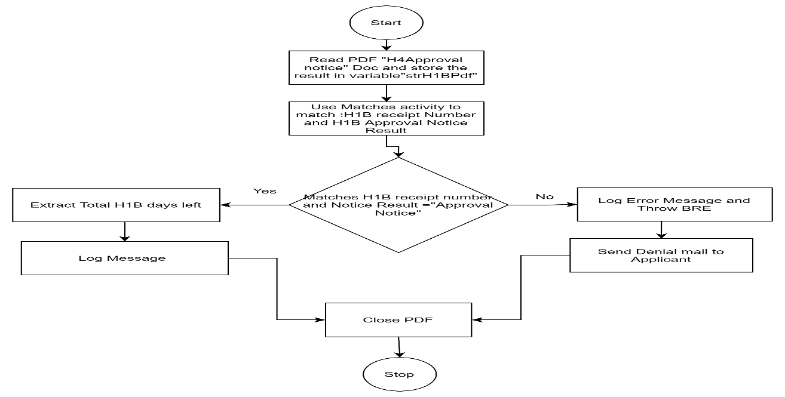

2- I140 VerificationProcess

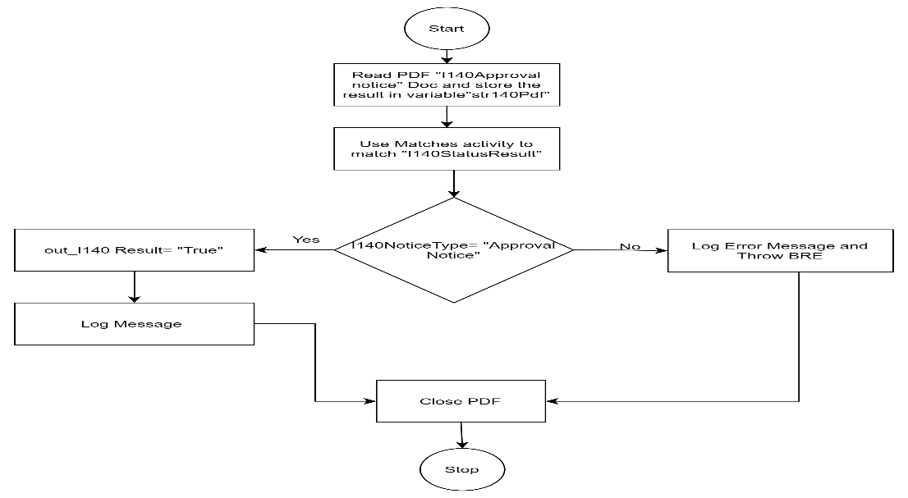

3- H4 ApprovalVerification

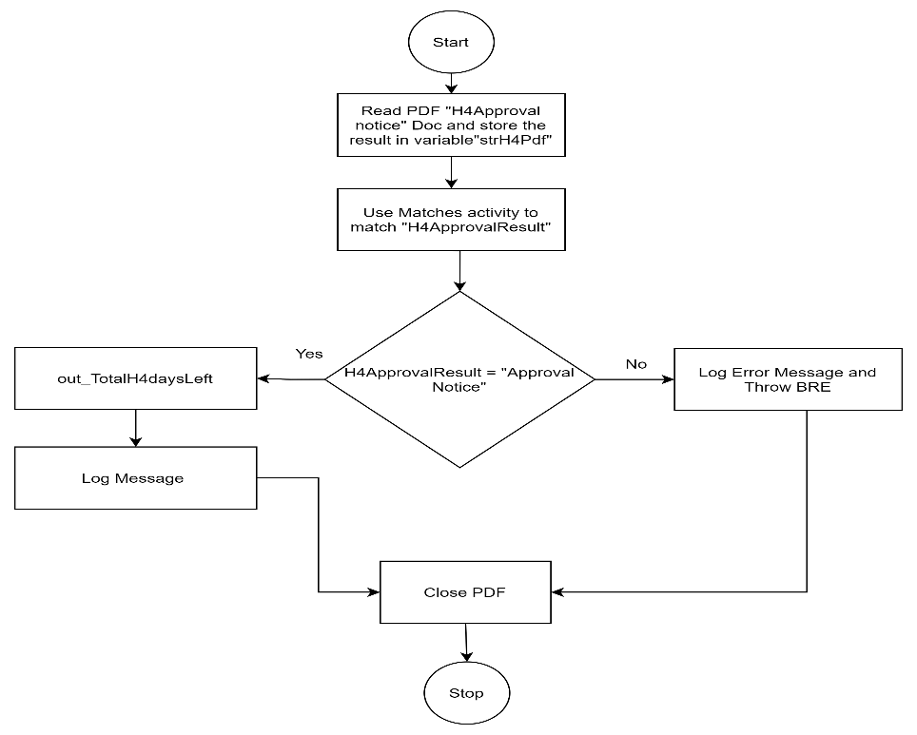

4- I94 validity Check

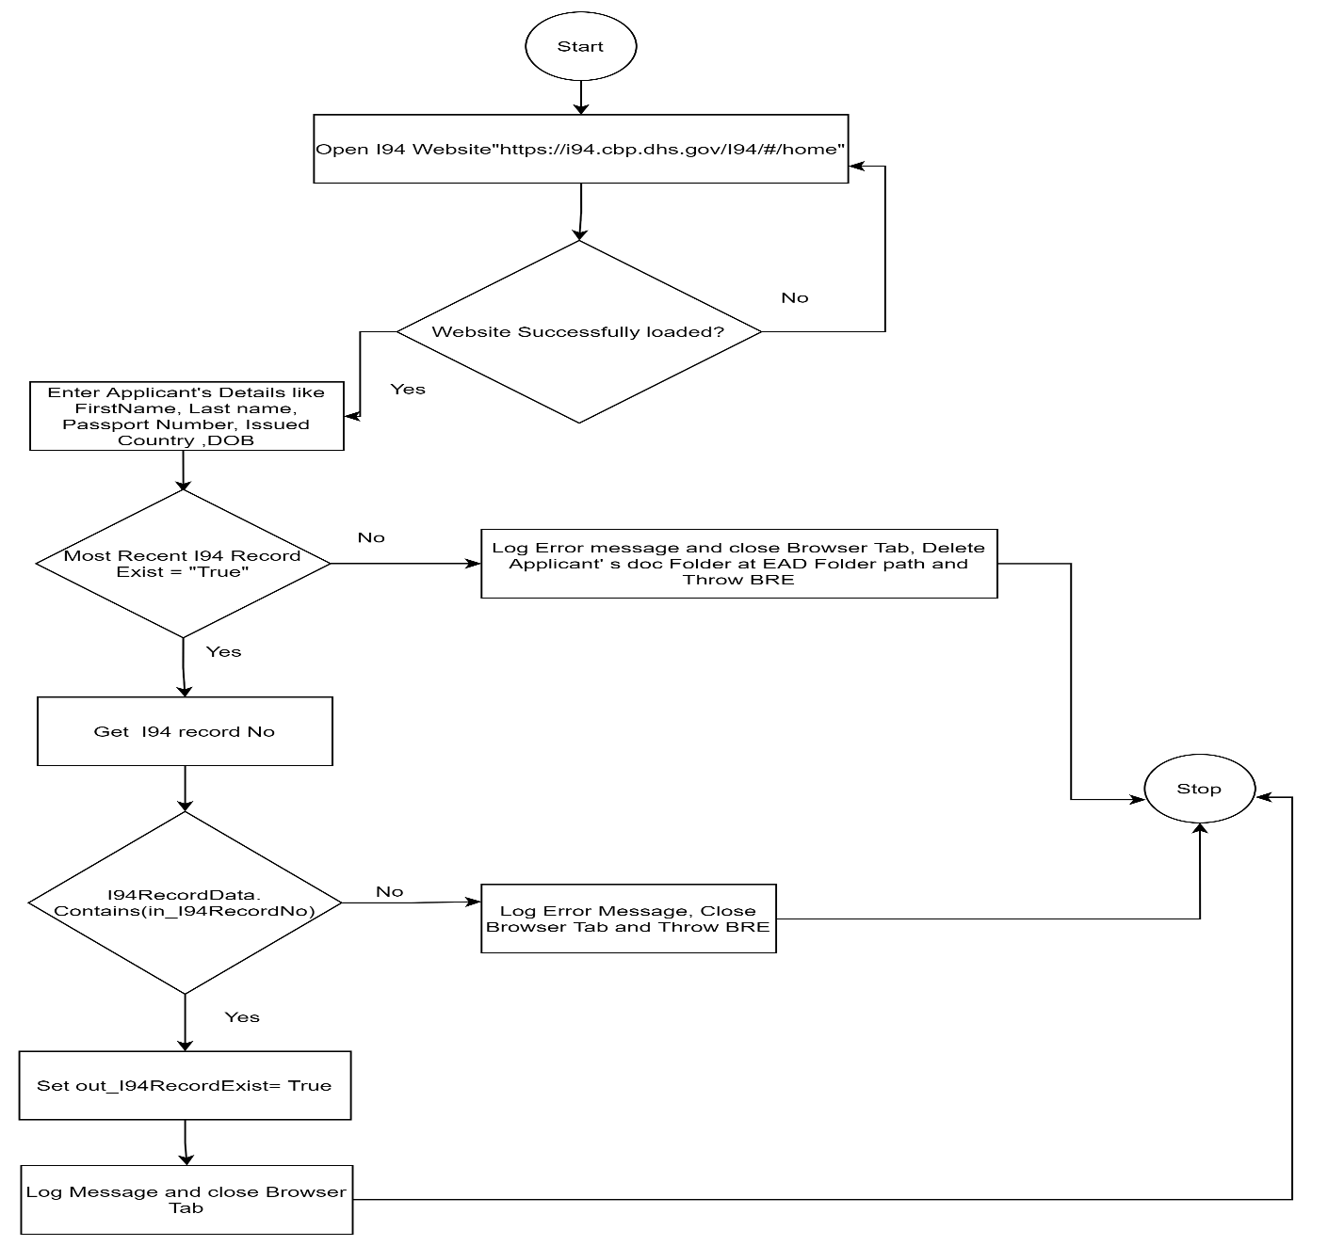

(IF ON GOOGLE DOCS GO TO INSERT DRAWING TO PUT YOUR DRAWING HERE)

## List of Packages

Include **the list of packages and the high-level description** for each of them, to explain each one's purpose:

|  |  |  |
| --- | --- | --- |
| # | Package Name | High-Level Description |
|  | EmploymentAdjudicationProcess_Dispatcher | Workflow Files for EAD_Dispatcher |
|  | EmploymentAdjudicationProcess_Processor | Workflow Files for EAD_Processor |

*Add more rows to the table to include all the project names and versions. No fields should be left empty. Use “N/A” for the items that don't apply to your project.

## Master Project Runtime Details

Details of the automated process:

|  |  |  |
| --- | --- | --- |
| # | Item | Details  (Fill in with free text. If the section does not apply to your automation, mark the field as “N/A”. No empty fields. ) |
| 1 | Production Environment Details | DESKTOP-NKEL750, "C:\Users\itabh\Documents\UiPath\Employment Adjudication Process_Dispatcher"  "C:\Users\itabh\Documents\UiPath\Employment Adjudication Process_Processor" |
| 2 | Prerequisites to run | UiPath Robot and studio should be installed, Google Chrome Browser should be available on the system and UiPath Extension should be added to the browser. User should have login access on UiPath Orchestrator “Udacity”Tenant. Gmail security setting for [purnima.work.953@gmail.com](mailto:purnima.work.953@gmail.com) “Less secure app access should be enabled. |
| 3 | Input Data | Emails having .zip folder attachment subject line as ” Immigartion_H4_i765” |
| 4 | Expected Output (output data) | Approval, Denial or RFE Emails to the applicant. |
| 5 | How to start the automated process? | Give the run command from UiPath studio or Processes can be called from the Orchestrator as well. |
| 6 | Resuming the process from a particular step | N/A (Bot will retry incase I94 website has not loaded properly) |
| 7 | Reporting  queues reporting, Kibana or another platform | N/A (Out of Scope) |
| 8 | Manual Error Handling  roll back or manually complete failed transactions. Procedures to reset the item. Ex “set status as investigating” | If Attachment folder name is incorrect Format- Send the information about such cases to the team who sends the email and ask them to resend it in correct format.  In EAD_Processor flow- Application exception can be manually filtered and verified and validated by the human users. |
| 1. How to resume the process in case of error | NA |
| 1. How to manually fix transactions with error | Application exception cases can be manually checked. If volume of App exception cases are very high then resend all those cases to the respective team who send the email and asked them to resend the email. Attachment folder name is incorrect Format- Send the information about such cases to the team who sends the email and ask them to resend it in correct format. If already same folder is available means duplicate record scenario, check those cases manually. |
| 9 | Use of Orchestrator | Yes |
| 1. Password Policies   specific compliance requests? | Secure String type |
| 1. Stored Credentials   Never hard code credentials in the workflow | UserCredentials |
| 1. List of Asset Names | H4EADFolderPath, I94Online,H1BapprovalNotice,I140ApprovalNotice,H4ApprovalNotice, DownLoadZipPath,I765Form |
| 1. List of Queues Name | EAP |
| 1. Schedule Details | N/A (Depends on Business needs) |
| 10 | Recommended Resolution | We can make process more scalable with the use of multiple robots and triggers in Licensed version of Orchestrator. |

# Project Details

In this section describe all the projects that compose the automated process.

For each project, describe the workflow(s) in the logical order that they are called in.

If the workflow is a flowchart, also include the exported image from Studio.

If the automated process is composed of multiple projects, copy paste and fill in the table below for each project with its specific details (there are 2 here already, assuming a dispatcher and performer project)

## Project Name: <Employment Adjudication Process_Dispatcher>

General information about the process selected for RPA prior to automation.

|  |  |  |
| --- | --- | --- |
| # | Item Name | Details  Fill in with free text. If not applicable, mark the field as “N/A". No empty fields. |
| 1 | Environment used for development  name, location, configuration details etc | DESKTOP-NKEL750, "C:\Users\itabh\Documents\UiPath\Employment Adjudication Process_Dispatcher" |
| 2 | Environment prerequisites  OS details, libraries, required apps | UiPath Robot and studio should be installed, Google Chrome Browser should be available on the system and UiPath Extension should be added to the browser. User should have login access on UiPath Orchestrator “Udacity”Tenant. Gmail security setting for [purnima.work.953@gmail.com](mailto:purnima.work.953@gmail.com) “Less secure app access should be enabled. |
| 3 | Logging level | Info, Fatal, Error |
| 4 | Details about automation  if the apps were automated using UI Automation, Image & Text | PDF automation, Email automation |
| 5 | In case of attended bot, can the user operate the computer while the robot is running? | No |
| 6 | Repository for project  where the developed project is stored | "C:\Users\itabh\Documents\UiPath\Employment Adjudication Process_Dispatcher" |
| 7 | List of reused components | Element Exist, If pop up exist while opening the PDF File, Read and Extract Emails(with required modifications) |
| 8 | Custom logs defined in the workflows  where Throw Activity was used or custom log message was defined | Mail Login Process Steps-“ "Emails have been successfully fetched with subjectline Immigartion_H4_I765"  DuplicateRecord-“Duplicate Record Found”  Download attached zip Folder and Unzip files- "Zip folder has successfully extracted at the"+inOut_H4EADPath+"\"+AttachmentName  Folder name is in incorrect Format- “Invalid Folder Name”+AttachmentName  Create Queue Item- “Bot has successfully Created the queue Item.”  IncorrectVersionOfForm- “Form version was incorrect” |
| 9 | Frequent errors found in the development phase | Sometimes send hot “cntrl+1” doesn’t work or may be little late |
| 10 | Workarounds used in the automation phase | Used hard coded delays but not always necessary. |
| 11 | Configuration method  assets, excel file, Json file | Get Asset, Get Credentials |
| 12 | Configuration details  path for input files, configuration Orchestrator assets used | Orchestrator Assets and Credentials- H4EADFolderPath, ZipFolderPath, I765Form, UserCredentials |
| 13 | Workflow File Export List  Use the project mapping tool |  |

### Workflow(s) specific to the Project

Define below all the workflow files (.xaml files) used in the project, with the Input and Output data.

|  |  |  |  |  |
| --- | --- | --- | --- | --- |
| # | Workflow File Name | Description | Arguments | Comments |
| 1 | MainFlow | Main.xamlFile | N/A | Variables like- H4EADFolderPath, UserName, Password, ZipFolderPath, I765Form  Are used to save Asset values |
| 2 | ReadEmailWorkflow | ReadEmailWorkflow.xamlFile | inout_H4EADFolderPath, in_UserNmae, in_Password, in_DownLoadZipPath, in_I765Form | Multipleactivities like GetImapmail message, assign, Matches, Extarct/ UnzipFiles etc activities are used |
| 3 | CreateQueueItemWorkflow | CreateQueueItemWorkflow.xamlFile | In_EADFilePath, in_EADForm | Multiple activities like, Add queue item, Matches, Assign, if condition etc are used in this workflow |

## Project Name: <Employment AdjudicationProcess_Processor>

General information about the process selected for RPA prior to automation.

|  |  |  |
| --- | --- | --- |
| # | Item Name | Details  Fill in with free text. If not applicable, mark the field as “N/A". No empty fields. |
| 1 | Environment used for development  name, location, configuration details etc | DESKTOP-NKEL750, "C:\Users\itabh\Documents\UiPath\Employment Adjudication Process_Processor” |
| 2 | Environment prerequisites  OS details, libraries, required apps | UiPath Robot and studio should be installed, Google Chrome Browser should be available on the system and UiPath Extension should be added to the browser. User should have login access on UiPath Orchestrator “Udacity”Tenant. Gmail security setting for [purnima.work.953@gmail.com](mailto:purnima.work.953@gmail.com) “Less secure app access should be enabled. |
| 3 | Logging level | Fatal, Info, Error |
| 4 | Details about automation  if the apps were automated using UI Automation, Image & Text | PDF automation, WebAutomation, Email Automation |
| 5 | In case of attended bot, can the user operate the computer while the robot is running? | No |
| 6 | Repository for project  where the developed project is stored | "C:\Users\itabh\Documents\UiPath\Employment Adjudication Process_Processor” |
| 7 | List of reused components | Element Exist, If pop up exist while opening the PDF File, Read PDF text, Start Process, Matches activities are frequently used in all the subflows of this process |
| 8 | Custom logs defined in the workflows  where Throw Activity was used or custom log message was defined | ExtarctAssetValuesFromOrchestrator- “Folderpath+" "+I94Website+" "+H1BApprovalNotice+" "+I140ApprovalNotice+" "+H4ApprovalNotice+" "+"Asset values have been successfully extraxted from the Orchestrator"  MainFlowchart- "No queue item available to process"  WrongProcessingGroup-“ "Items is in wrong processing queue"  H1BVisaVerificationProcess- "Total days left on H1B visa is"+" "+out_TotalH1BDays.ToString  H1BVisaVerificationProcess- H1BApprovalDocIssue-“Please ask Applicant to resubmit the H1B approval Notice”  I140VerificationProcess-“H4Applicant is eligible for EAD”  I140VerificationProcess-"Discrepency in Primary Visa holdre's I140 ApprovalNotice Document"  H4ApprovalVerification- "Total days left on H4 Visa :"+" "+out_TotalH4Days.ToString  H4ApprovalVerification- " Issue with H4 approval notice document"  I94 ValidityCheck- “I94 Website successfully loaded”  I94ValidityCheck-“All the required details are successfully entered on the site ” "+in_FirstName+" "+in_LastName+" "+in_Birthdate.ToString+" "+in_BirthMonth+" "+in_BirthYear+" "+in_PassportNumber+" "+in_IssuedCountry  I94ValidityCheck-“ "I94 records record matches and fetched I94 record no is :"+in_I94recordNo  I94ValidityCheck- “"I94 record mismatch. Please check with I94 team."  I94ValidityCheck-“No record found for traveler”  Processingof QueueItems-“ "Applicant's case has been approved for EAD"  ProcessingofQueueItems- "Applicant's case has been denied for the EAD"  ProcessingofQueueItems- "Applicant's case has been denied for the EAD"  ProcessingofQueueItems- exception.Source+exception.Message(Exception Scenario)  ProcessingofQueueItems-exception.source +" "+" :"+exception.Message(BRE Scenario) |
| 9 | Frequent errors found in the development phase | Sometimes send hot “cntrl+1” doesn’t work or may be little late, |
| 10 | Workarounds used in the automation phase | Hard coded delay used but not always required. |
| 11 | Configuration method  assets, excel file, Json file | Get assets, Get Credentials |
| 12 | Configuration details  path for input files, configuration Orchestrator assets used | Orchestrator Assets and Credentials- H4EADFolderPath, UserCredentials, I94Online, H1BapprovalNotice, I140ApprovalNotice, H4ApprovalNotice |
| 13 | Workflow File Export List  Use the project mapping tool |  |

### Workflow(s) specific to the Project

Define below all the workflow files (.xaml files) used in the project, with the Input and Output data.

|  |  |  |  |  |
| --- | --- | --- | --- | --- |
| # | Workflow File Name | Description | Arguments | Comments |
| 1 | Main | Flowchart Main.xaml | N/A | Variables TranscationItem, FirstName, LastName, DOB, I94RecordNo,PassportNo,PassportNo,SSN, IssuedCountry, Eligibility,H1BreceiptNumber,UserId, Password,ArrDOB,BirthDate,Month, Year, CompleteMonth,ApplicantEmail,I94Website,H1BapprovalNotice,I140ApproavlNotice,H4approvalNotice are used in the flow |
| 2 | Processing ofQueueItems workflow | Processing ofQueueItems workflow.xaml | In_SSN, in_FolderPath, in_UserId,in_Password,in_TransactionItem, in_ApplicantMail,in_H1BreceiptNumber,in_PassportNo, in_IssuedCountry,in_Month,in_Date,in_Year,in_LastName,in_FirstName,in_I94RecordNo,in_I94Website,in_H1BnoticePath,in_I140DocPath,in_H4NoticePath |  |
| 3 | H1BVisaVerificationProcessFlow | H1BvisaVerificationProcessFlow.xaml | In_SSN,in_FolderPath,in_H1BreceiptNumber,out_TotalH1Bdays,in_H1BApprovalNotice |  |
| 4 | I140VerificationProcessWorkflow | I140VerificationProcessWorkflow.xaml | in_SSN,in_FoldrePath,in_I140ApprovalNotice,out_I140result |  |
| 5 | H4approavlVerificationworkflow | H4ApproavlVerificationWorkflow.xaml | out_TotalH4days, in_FolderPath,in_SSN,in_H4ApprovalNotice |  |
| 6 | I94ValidityCheckWorkflow | I94ValidityCheckWorkflow.xaml | In_PassportNumber,in_IssuedCountry,in_BirthMonth,in_BirthDate,in_BirthYear,in_FirstName,In_LastName,out_I94RecordExist,in_I94RecordNo,in_I94Website,in_FolderPath,in_SSN |  |

# Compliance Considerations and Reporting Requirements

* N/A

# Other Details

## Future Improvements

* If the correct standard documents are used, we can design the flow in a better way. We don’t need to use Regex to extract and match the required details. Anchor base, find element etc. like better features can be used.
* For more deep-down verification if there is a centralized database system where applicant details are saved based on SSN or any other unique identification number, that can help in further verification.
* Rather than sending the documents on common email, they can be saved on a centralized common folder and that path also be saved in the Orchestrator Asset section.

## Debugging Tips

* Pdf reading, if the key Cntrl+1 doesn’t work and give exception then pass the command manually while running the process in debug mode.
* To check happy flow in I94 verification hard code the correct values like First name, last name, Birthdate, Month, Year, Passport number, issued country in the flow. Website maintains the data of all USA travelers.

## Other Remarks

This project is just a prototype and actual document, and processing format will be different. Only intent was to showcase use of RPA can make the process fast and error free. Currently the department is processing the cases in 8 months to a year. Current processing time for standalone H4 EAD cases by manual agents are 12- 15 mins per case.

# Post UAT Specifications

* Average duration per transaction (varies depending on the Test environment): 5 Mins :50seconds
* Recommended number of robots for the specified volumes: - Depends on business need
* Specified schedule- N/A

# Glossary

* **Master project** - the overall output of the development, containing one or multiple projects that together cover the scope of the robotic process automation.
* **Project** - a UiPath Studio project containing one or multiple workflow files. A project can be converted to a package and run independently, covering a particular scope within the master project. The project is used when defining the development and support phase of the automation.
* **Package** - the output of compiling a project. A package can be deployed on the robot machine and be executed by the robot service. Only one package can be executed at a given time by a robot. The package is used when defining the running phase of the automation
* **Workflow** - a component of the package, the workflow encapsulates a part of the project logic. The workflow can be of type: sequence, flowchart or state machine. a workflow is saved as an .xaml file inside the project folder. A workflow file can be invoked from another workflow and by default there is an initial workflow file that will run when executing the package.
* **Activity** - an action that the robot executes.
* **Sequence** - a workflow where activities are executed one after another, in a sequential order
* **Flowchart** - a workflow where activities are connected by arrows and the logic of the workflow can be easily followed in a visual manner. The flowchart can also be exported as an image from UiPath studio
* **State machine** - a more advanced way of organizing a workflow, similar to a flowchart.
* **BOR** - Back office robot
* **FOR** – Front office robot
* **Orchestrator** – Enterprise architecture server platform supporting: release management, centralized logging, reporting, auditing and monitoring tools, remote control, centralized scheduling, queue/robot workload management, assets management.